ParaView Design Project

# Alternator Visualization

The Alternator design was adopted from the web at GrabCAD.com, To visualize a subsystem of a car we can see the design of an Alternator. The Purpose of the Alternator is to convert mechanical energy from the chemical combustion from the engine into electrical energy by using the spin of the engines axel (joined by a rubber belt) to produce a Electromagnetic field which in turns produces a charge onto the coils and finally into the battery. This function allows the car to be self-sufficient storing energy while driving.

A screenshot of a cell phone

Description generated with high confidence

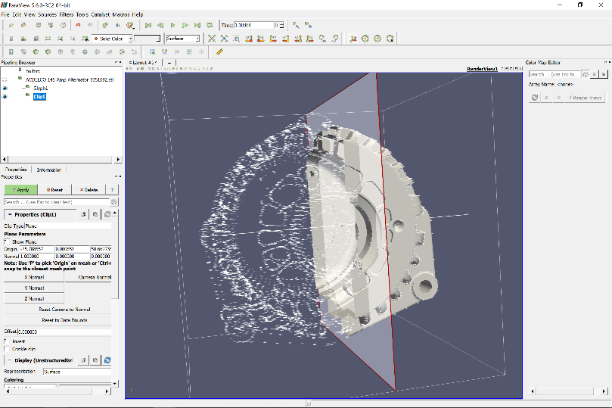The alternator to the right shows the ParaView implementation which can be viewed as a 3-D diagram. To implement animation we could use the Animation Tab to develop a 360 video for display.

We can also view the internal structure of the alternator, realize that this is only the encasing and is best used for dimensionality when implementing the electrical system within the Alternator.

# Human Trachea

This object was sculpted and developed on Autodesk Fusion 360 for the intent and purposes for the MDI Lab. Using the Visualization of 3D object will help medical professionals as well as Medical Engineers to develop better and proper methods for intubation of Endotracheal tubes. Using Fusion 360 we are able to design the 3D rendering of a tubular structure that branches out into smaller tubular structures, Given the time and resources a simulation can be developed to produce the inhalation and exhalation.

A screenshot of a computer

Description generated with very high confidence

Trachea Developed in Fusion 360

A screenshot of a cell phone

Description generated with very high confidenceThe Image above shows the structure and implementation of Trachea and Bronchus structure. You can also see a branching out of tubular structures which would branch out even further into the alveoli.

ParaView Implementation of the Trachea Model

# ­­Elevation Terrain

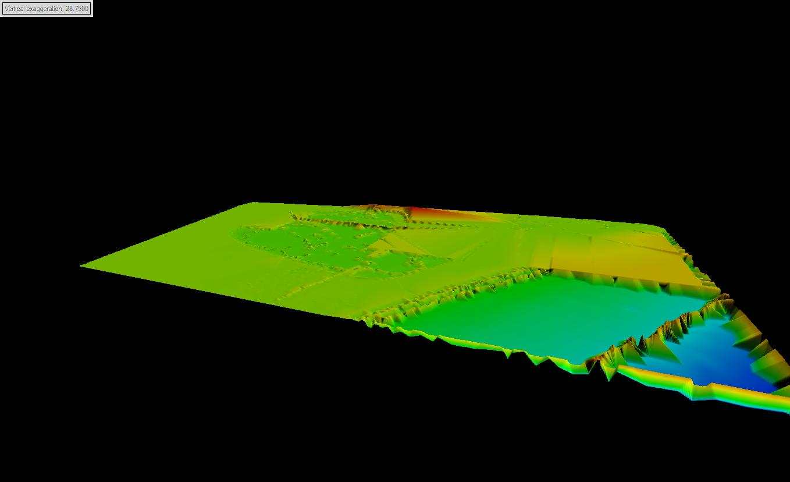The elevation suite for this animation was designed for the final project implementation. With the availability of Electronic Nautical Charts we are able to develop 3D animations that allow virtual view of the ground level of the Gulf of Mexico. This allows us aid the coast guard as well as help helmsman pilot through the ocean. Paraview was having errors when importing the file, thus was not able to be implemented onto the system.

Corpus Christi Sub Sea Level

Gulf of Mexico Sub Sea Level

